# **Task 3:**

# **Project: Event Management System using PostgreSQL.**

1. **Database creation**

CREATE DATABASE "EventsManagement"

WITH

OWNER = postgres

ENCODING = 'UTF8'

LC_COLLATE = 'English_United States.1252'

LC_CTYPE = 'English_United States.1252'

TABLESPACE = pg_default

CONNECTION LIMIT = -1

IS_TEMPLATE = False;

1. Table Creation

|  |  |
| --- | --- |
| Events | Attendees |
| *CREATE TABLE Events (*  *Event_Id INT,*  *Event_Name VARCHAR(30),*  *Event_Date DATE,*  *Event_Location VARCHAR(100),*  *Event_Description VARCHAR(200),*  *PRIMARY KEY (Event_Id)*  *);* | *CREATE TABLE Attendees (*  *Attendee_Id INT,*  *Attendee_Name VARCHAR(30),*  *Attendee_Phone NUMERIC,*  *Attendee_Email VARCHAR(30),*  *Attendee_City VARCHAR(20),*  *PRIMARY KEY (Attendee_Id)*  *);* |
|  |  |
| Registrations |  |
| *CREATE TABLE Registrations (*  *Registration_Id INT,*  *Event_Id INT,*  *Attendee_Id INT,*  *Registration_Date DATE,*  *Registration_Amount NUMERIC,*  *PRIMARY KEY (Registration_Id),*  *FOREIGN KEY (Event_Id) REFERENCES Events(Event_Id),*  *FOREIGN KEY (Attendee_Id) REFERENCES Attendees(Attendee_Id)*  *);* |  |

**2. Data Creation**

INSERT INTO Events

(Event_Id, Event_Name, Event_Date, Event_Location, Event_Description) VALUES

('101', 'AR Rahman', '2024-03-03', 'Chennai', 'Music Show'),

('102', 'Comicon 2023', '2023-11-19', 'Bangalore', 'Exhibition'),

('103', 'National Awards', '2023-11-12', 'Delhi', 'Movie'),

('104', 'I was not Ready Da!', '2024-01-06', 'Bangalore', 'Comedy'),

('105', 'Thangalan - Tamil', '2024-02-13', 'Kolkata', 'Movie');

SELECT * FROM Events;

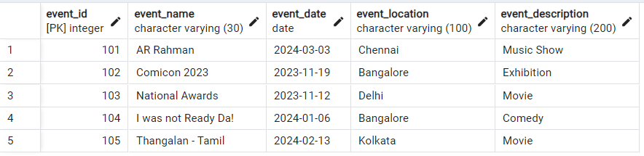

INSERT INTO Attendees (Attendee_Id, Attendee_Name, Attendee_Phone, Attendee_Email, Attendee_City) VALUES

('1001', 'Muskaan', '9999999991', 'Muskaan@gmail.com', 'Delhi'),

('1002', 'Rajat', '9999999992', 'Rajat@gmail.com', 'Delhi'),

('1003', 'Abhinav', '9999999993', 'Abhinav@gmail.com', 'Mumbai'),

('1004', 'Kundan', '9999999994', 'Kundan@gmail.com', 'Uttar Pradesh'),

('1005', 'Karishma', '9999999995', 'Karishma@gmail.com', 'Mumbai'),

('1006', 'Shivani', '9999999996', 'Shivani@gmail.com', 'Goa'),

('1007', 'Devashish', '9999999997', 'Devashish@gmail.com', 'Uttrakhand'),

('1008', 'Sarthak', '9999999998', 'Sarthak@gmail.com', 'Delhi');

SELECT * FROM Attendees;

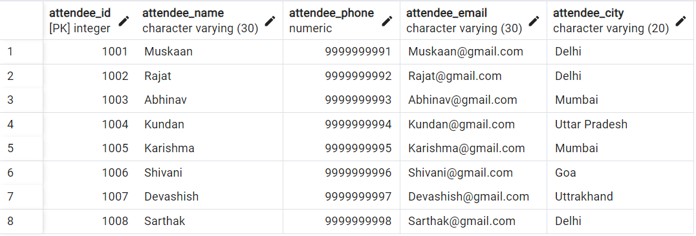

INSERT INTO Registrations

(Registration_Id, Event_Id, Attendee_Id, Registration_Date, Registration_Amount) VALUES

('10001', '101', '1001', '2023-10-12', '7500'),

('10002', '102', '1003', '2023-09-25', '1000'),

('10003', '103', '1002', '2023-10-29', '2000'),

('10004', '104', '1004', '2023-10-20', '500'),

('10005', '101', '1005', '2023-09-10', '7500'),

('10006', '103', '1008', '2023-09-15', '2000'),

('10007', '101', '1007', '2023-11-01', '7500'),

('10008', '102', '1006', '2023-11-05', '1000');

SELECT * FROM Registrations;

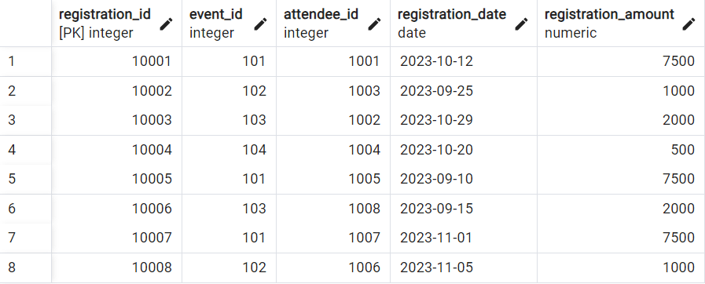

**3) Manage Event Details**

a) Insert New event

Insert INTO Events (Event_Id, Event_Name, Event_Date, Event_Location, Event_Description) VALUES

('106', 'Unheard Diaries', '2023-10-29', 'Delhi', 'Storytelling');

b) Update event's information

UPDATE Events

SET Event_Location = ‘Mumbai’ WHERE Event_Id = '104';

c) Deleting an event

DELETE FROM Events WHERE Event_Id = '105';

**4) Manage Track attendees and handle events**

a) Insert new attendee

INSERT INTO Attendees (Attendee_Id, Attendee_Name, Attendee_Phone, Attendee_Email, Attendee_City)

VALUES ('1009', 'Krishna', '9999999999', 'Krishna@gmail.com', 'Tamil Nadu');

b) Register attendee

INSERT INTO Registrations

(Registration_Id, Event_Id, Attendee_Id, Registration_Date, Registration_Amount)

VALUES ('10009', '101', '1009', '2023-11-11', '7500');

**5) Retrieve event information, generate attendee list, Calculate event attendee statistics**

WITH Event1 AS(

SELECT E.Event_id, E.event_name, E.event_date, E.event_location,

SUM(R.registration_amount) OVER(PARTITION by E.event_id) AS Amountgenperevent

FROM Events E JOIN Registrations R ON E.event_id = R.event_id

JOIN Attendees A ON A.attendee_id = R.attendee_id)

SELECT Event_id, event_name, event_location, Amountgenperevent

FROM Event1

GROUP BY 1,2,3,4

ORDER BY Amountgenperevent DESC;

